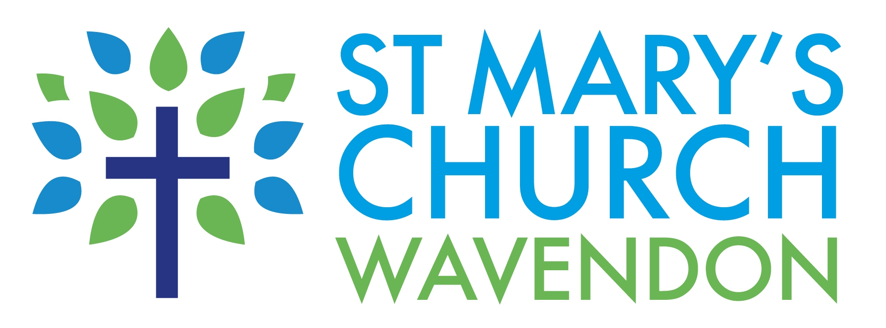
St.Mary’s Church, Wavendon
(A member of Walton Churches Partnership)
The Rectory, Walton Road, Wavendon, Milton Keynes, MK17 8LW
Tel: (01908) 582839; Email: matt.trendall.mk@gmail.com

Gift Aid Declaration

- I want St Mary’s Church Wavendon to treat all donations I have made for the four years prior to this year, and all donations I make from the date of this declaration until I notify you otherwise, as Gift Aid donations. I am a UK tax payer and understand that if I pay less income tax and/or capital gains tax than the amount of Gift Aid claimed on all my donations in that tax year it is my responsibility to pay any difference.

Forename(s)
Surname
Address
Postcode
Your usual signature
Date

Note:
- If you pay a higher rate of tax you may be able to claim further tax relief by completing a self-assessment tax return.
- You may cancel this declaration at any time in writing by contacting the Treasurer of St Mary’s, Wavendon.
- This declaration will supercede and replace any covenant which you may have had with St Mary’s.

